Tutorial:

Using HortonWorks Sandbox 2.3 Locally

Sayed Hadi Hashemi

Last update: August 3, 2015

# Overview

**Welcome**

Before diving into Cloud Applications, we need to set up the environment for doing tutorials or programming assignments. This course uses an all-in-one virtual machine made by Hortonworks. This tutorial covers the critical skills needed to work with this VM.

**Objectives**

Upon completing this tutorial, students will be able to:

* Set up an all-in-one Hadoop installation
* Start and Stop the Virtual Machine
* Install “nano” Text Editor
* Connect to the VM through SSH

# Requirements

**Hypervisor**

To run the all-in-one virtual machine you need to have a hypervisor such as **Virtual Box** installed. You can grab a copy of **Virtual Box** for free from this URL.

|  |  |
| --- | --- |
| ../../../Downloads/1435362144_globe.png | https://www.virtualbox.org/wiki/Downloads |

**SSH Client**

For command line steps you need a SSH client:

* For Linux and OS X, you should already have it installed.
* For Windows, you can download a free copy of **Putty** from the following URL.

|  |  |
| --- | --- |
| ../../../Downloads/1435362144_globe.png | http://www.chiark.greenend.org.uk/~sgtatham/putty/download.html |

# Setup Hadoop Virtual Machine

**Step 1:** Download the Hortonworks Sandbox (Sandbox) Image:

Download the **Virtual Machine for VirtualBox** from the following link:

|  |  |
| --- | --- |
| ../../../Downloads/1435362144_globe.png | http://hortonworks.com/products/hortonworks-sandbox/#install |

You may be asked to fill out a form before you can proceed to download.

As of July 2015, the latest version is “HDP 2.3 on Hortonworks Sandbox” (8.08GB).

|  |  |
| --- | --- |
|  | For more information about this virtual machine and details about the installation process, please refer to the Install Guide at:  http://hortonworks.com/products/hortonworks-sandbox/#install |

**Step 2:** Open **VirtualBox**; then select **File > Import Appliance …**.

**Step 3:** Follow the instructions to import the downloaded file. Make sure the VM uses the following settings:

|  |  |
| --- | --- |
| Ram | 2048 MB |
| CPU | 2 |

**Step 4:** Wait until the import process is done.

# Start HDP Virtual Machine

**Step 1:** From the main windows of **Virtual Box** select the “HortonWorks Sandbox” VM; then click on **start**.

**Step 2:** Wait for a few moments until you see the login screen on the virtual machine window.

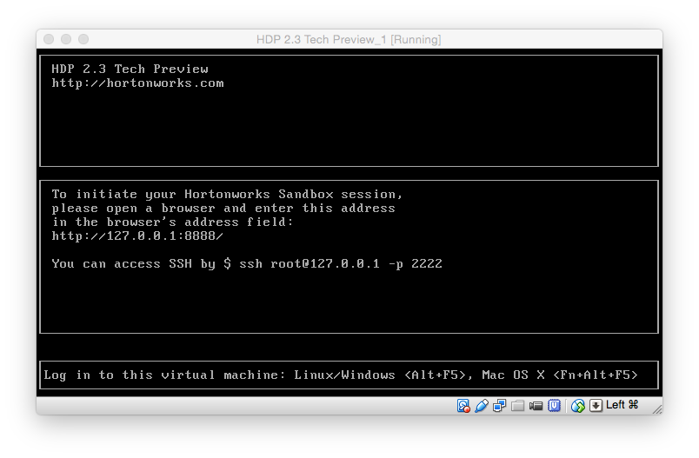

# Connect to the Virtual Machine

**Step 1 (OS X, Linux):** Open the terminal on your machine (not the virtual machine), and log in to the virtual machine via SSH protocol. The password is **hadoop**. (Ignore the leading # in the commands. It is just an indicator that the command has to run in a terminal.)

|  |
| --- |
| # ssh root@127.0.0.1 -p 2222 |

**Step 1 (Windows):** Open **Putty** on your machine, and log in to the virtual machine via SSH protocol using following information:

|  |  |
| --- | --- |
| Server | 127.0.0.1 |
| Port | 2222 |
| Username | root |
| Password | hadoop |

**Step 2:** After successfully logging in, you should see a prompt similar to the following:

|  |
| --- |
| [root@sandbox ~]# |

|  |  |
| --- | --- |
|  | Ignore the leading # in the commands.  It is just an indicator that the command has to run in a terminal. |

# Install “nano” Text Editor

If you are new to Linux, you might find it challenging to use the default text editor in the terminal. Therefore, it is recommended you use **nano.** Unfortunately, nano is not installed by default in the HDP Sandbox. Fortunately, it is relatively easy to install.

**Step 1:** Run this command, and follow the installation instructions:

|  |
| --- |
| # yum install nano |

**Step 2:** After the installation is done, check the installation:

|  |
| --- |
| # nano |

**Step 3:** Quit **nano**.

# Stop HDP Virtual Machine

**Step 1:** Run the following command from the SSH Terminal:

|  |
| --- |
| # poweroff |

**Step 1 (Alternative):** From the main windows of **Virtual Box,** right click on the “HortonWorks Sandbox” VM; then select **Close > ACPI Shutdown**.

**Step 2:** Wait for a few moments until the VM has fully shut down.

|  |  |
| --- | --- |
|  | Always stop the VM after you are done to prevent performance effects on your workstation. |